PPTP to SSTP
You can change an existing PPTP connection into an SSTP by doing the following:
1) Click on the notification bar and click on the arrow next to VPN
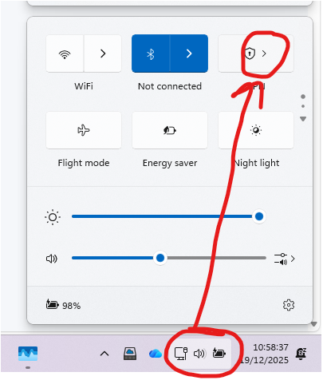
2) Click on more VPN settings
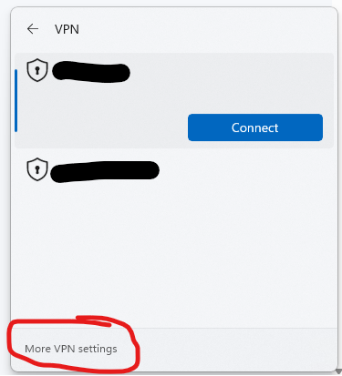
3) Click on the down arrow next to the VPN and click Advanced options
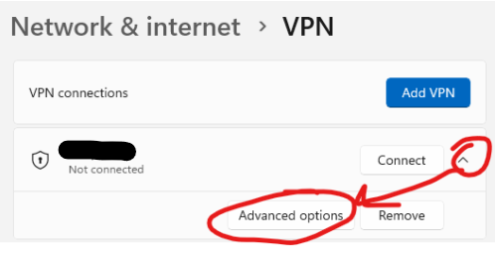
4) Click More VPN properties - Edit
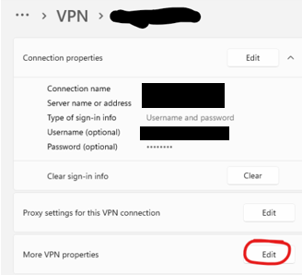
5) In the dialogue box that comes up Go to the Security Tab and change Type of VPN from PPTP to SSTP and click ok
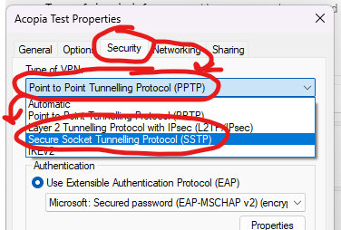

That should be it, it should now connect as an SSTP VPN

